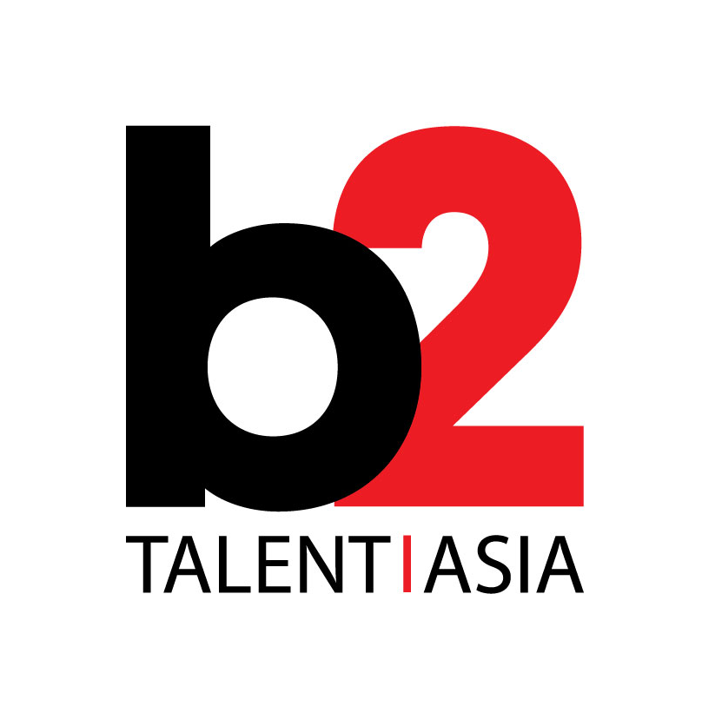

***b2 Music set to release ‘SPIN presents Indie Asia Vol. 2’***

*A snapshot of the best emerging Indie & Alternative Music in Asia*

**Hong Kong— March 13, 2020**

b2 Music, a division of B2 Talent Asia, announced today that Volume 2 of its’ compilation album series *SPIN presents Indie Asia* will be released worldwide on March 13, 2020. The album will be distributed through NetEase in China and via Kobalt / AWAL throughout the rest of the world.

The second album in the *SPIN presents Indie Asia* series, this volume includes fifteen tracks from top emerging artists and bands from across Asia. Six of the tracks are exclusives, which can be found only on this album.

Notable songs include *I’ll Have what She’s Having* by of-the-moment Korean-UK duo WOOZE, Hong Kong-bred SXSW-alums David Boring’s *Jane Pain* and Cambodia’s leading lady Miss Sarawan’s single *Mun Snea Ha.*

Jonathan Serbin, CEO of b2, stated, “We are thrilled to release the second album in the *SPIN presents Indie Asia series*. The compilation provides a snapshot of some of the best unsigned bands and emerging artists from across Asia. As with the other album series – *Billboard presents Electric Asia* and *Vibe presents Urban Asia* – the record provides a snapshot of some of the most exciting talent from across this region. We are excited to share with the world some of the great music coming out of Asia.”

Sean Dinsmore, A&R Director at b2 added, “This album features tracks from across Asia and highlights a wide variety of genres. From Cambodian Retro-Soul and Rap, to Japanese Power Pop, to Korean Nu Wave to Chinese Electronic Ambient and back, the songs display the wide of diversity styles throughout the region. Of course, Rock & Indie make a strong showing from bands like SOKOI from Laos, and even Punk from Shanghai’s Roundeye. But many of the songs also touch more esoteric parts of the indie landscape, including modern Ska, Art Rock, and more.”

* * *

**About b2 Holdings Ltd.**

**B2 Holdings Ltd.** is a Hong Kong-based talent management company, record label, social media & entertainment advisory firm. B2 represents established and emerging Asian talent, as well as Western talent and music management companies seeking opportunities in the Asian market. Additionally, B2 Music, B2’s record label, focuses on presenting the best Asian music to an international audience. See www.b2talentasia.com.

Outlet Mall; launched Singapore-based companies with

The company recently acquired the Audience, one of the world’s largest publishers of

Sony Picturestudios across its multi-ntertainment based platforms. With around 9,000 employees, AAHG is headquartered in the UAE, with representative offices across 20 countries globally.

###